Project Title
Venue
Project Leader Name:__________________
Project Leader Picture: kjg

- Introduction:
Introduction / summary of the project
- Project Venue:
It can be map and landmark picture ( refer the example)
- Objectives:
At least 3-4 objectives
- Target Community:
The target community for the project, how many people, who are they, why choose them
- Methods - Travel, procedures and activities
- Name of collaborative partners and their role: - University, Institution of Education, NGO, Civil Society
- Total Project Cost
- Result and Impact
- Project Sustainability Value
- Challenges
What are the challenges before, during and after project and how to overcome the challenges?
- Improvement
How to improve the project
- Future plans
What is the future plans for the community and the sustainability of the project?
- Experts project
List down all project members
- Acknowledgement
- Best 10 Pictures
to show the project activities
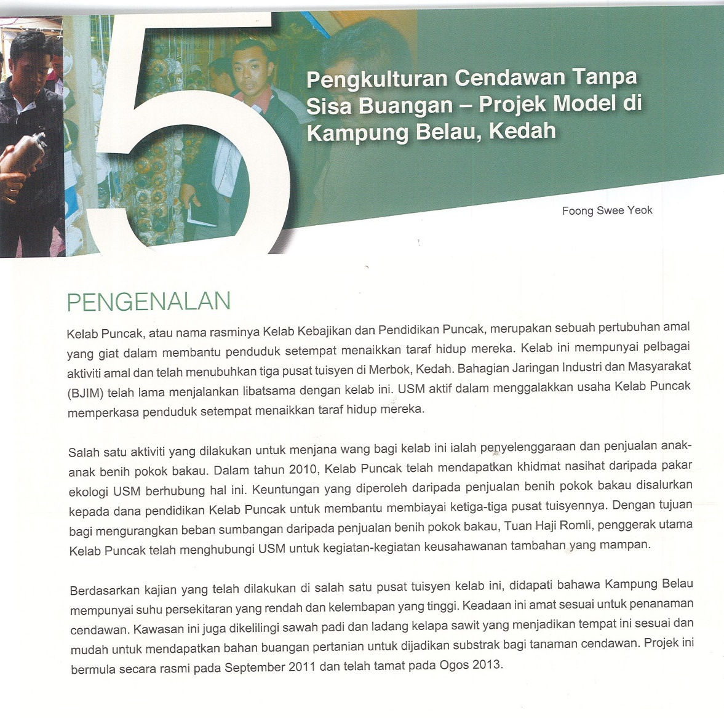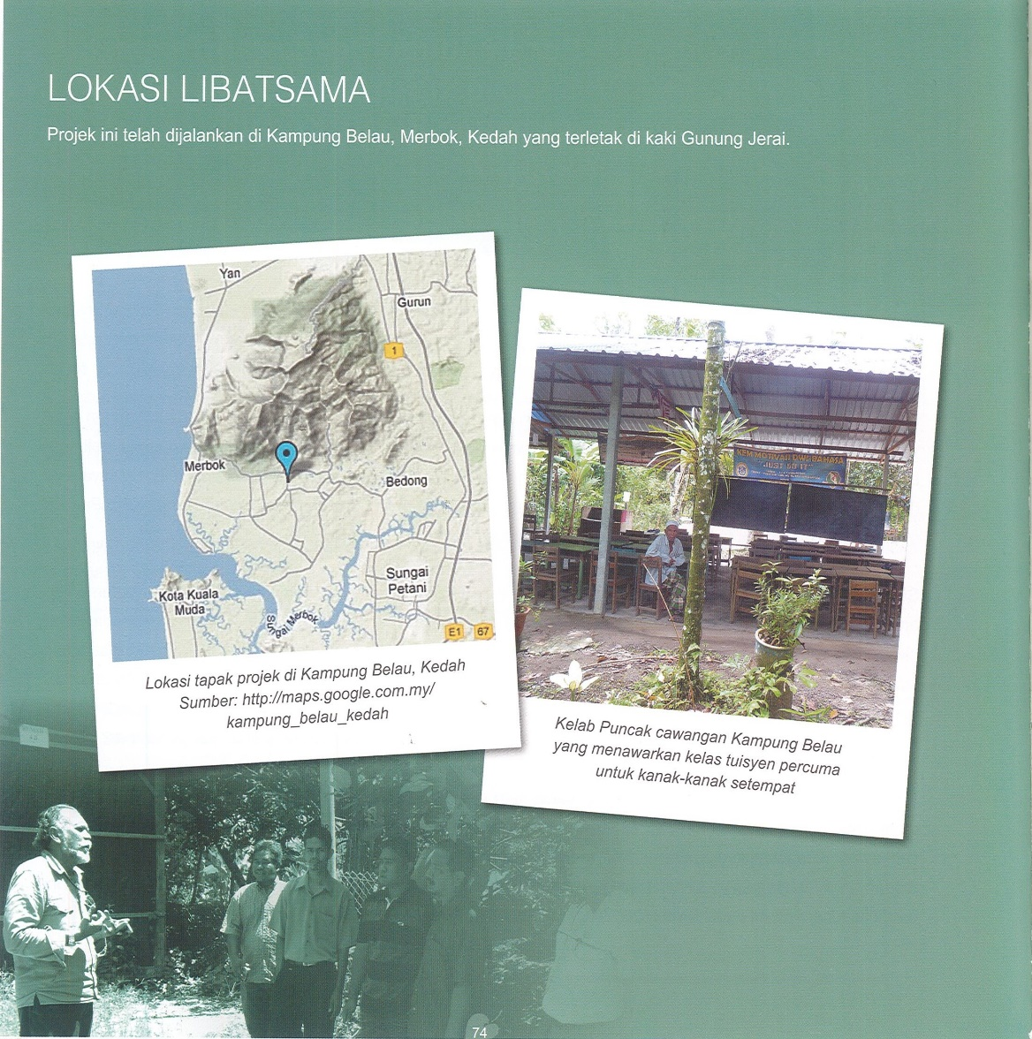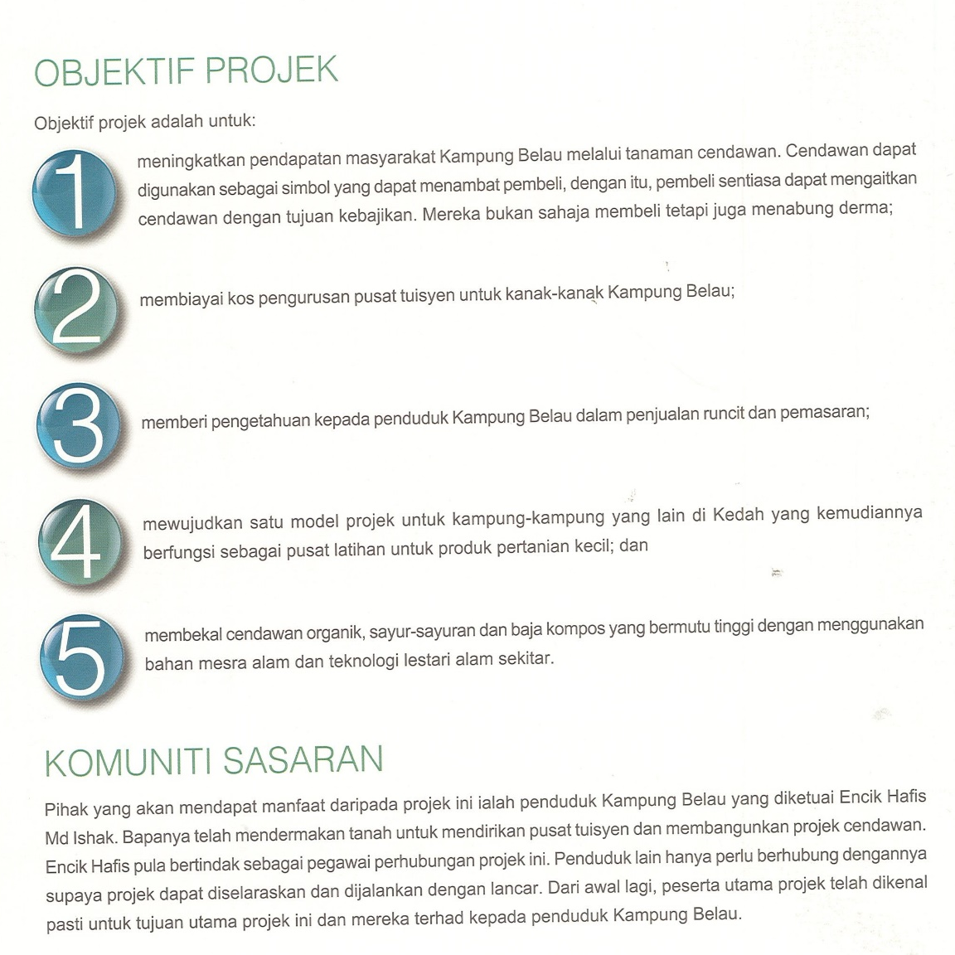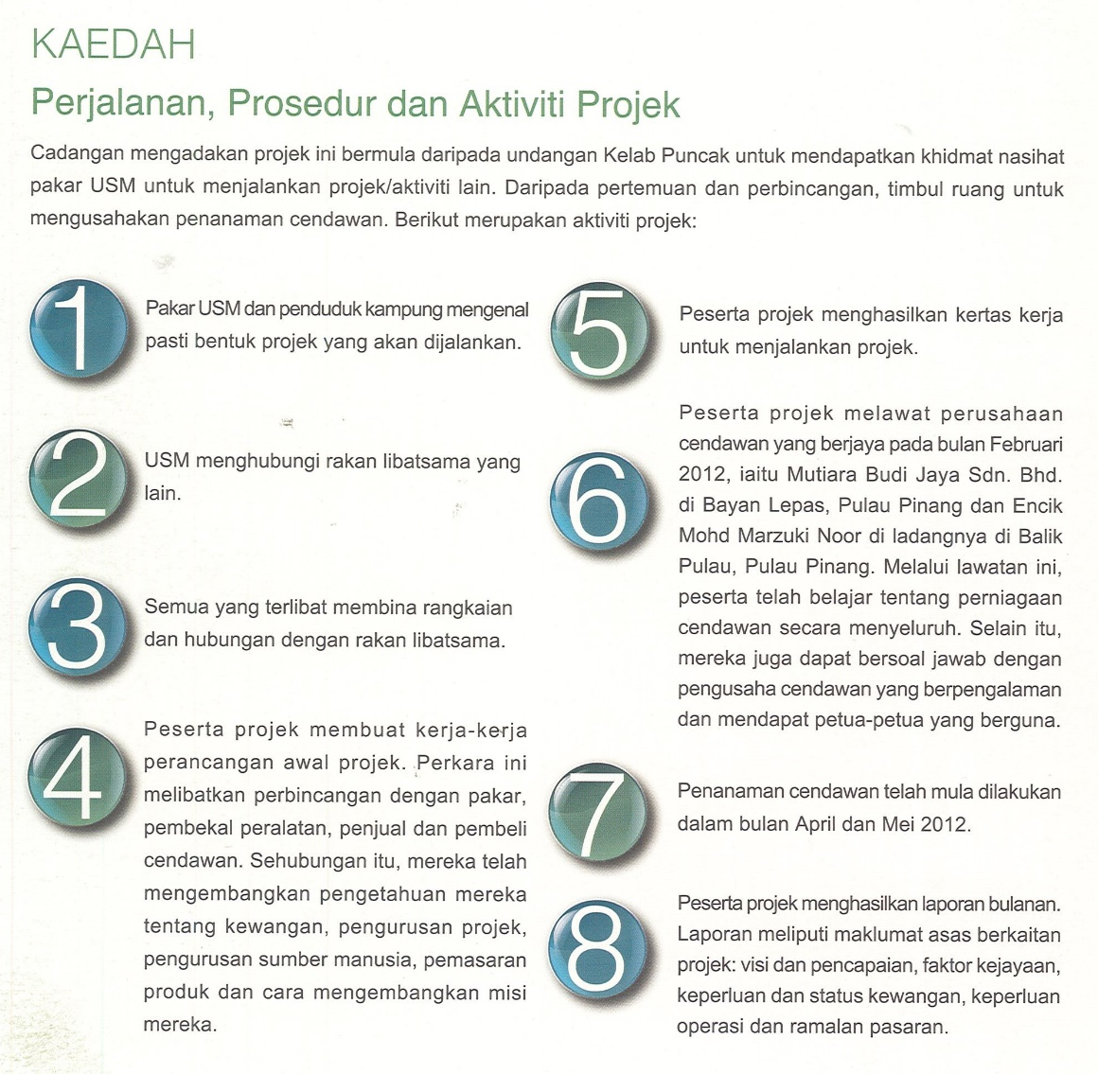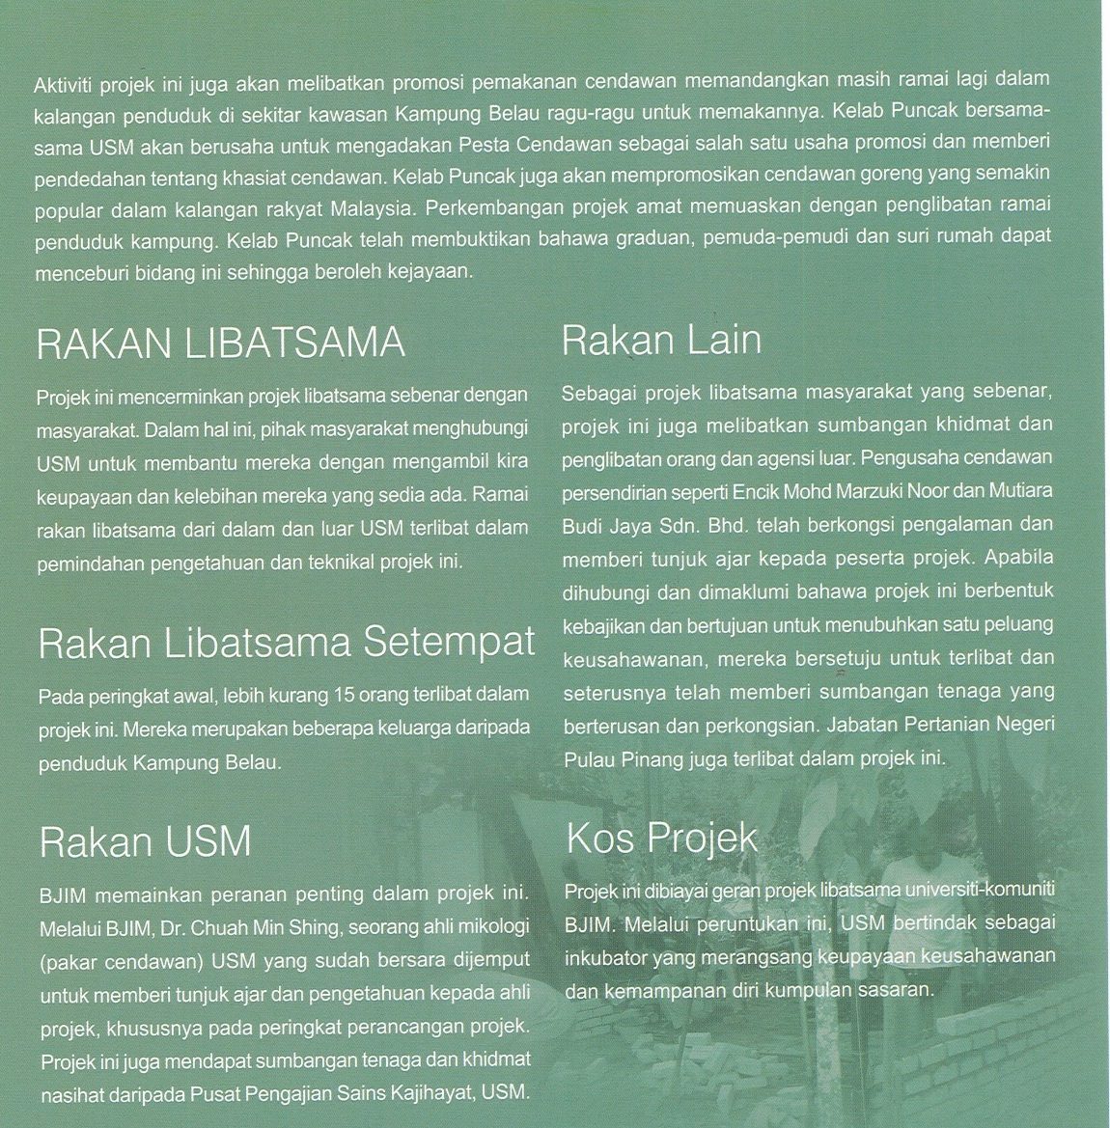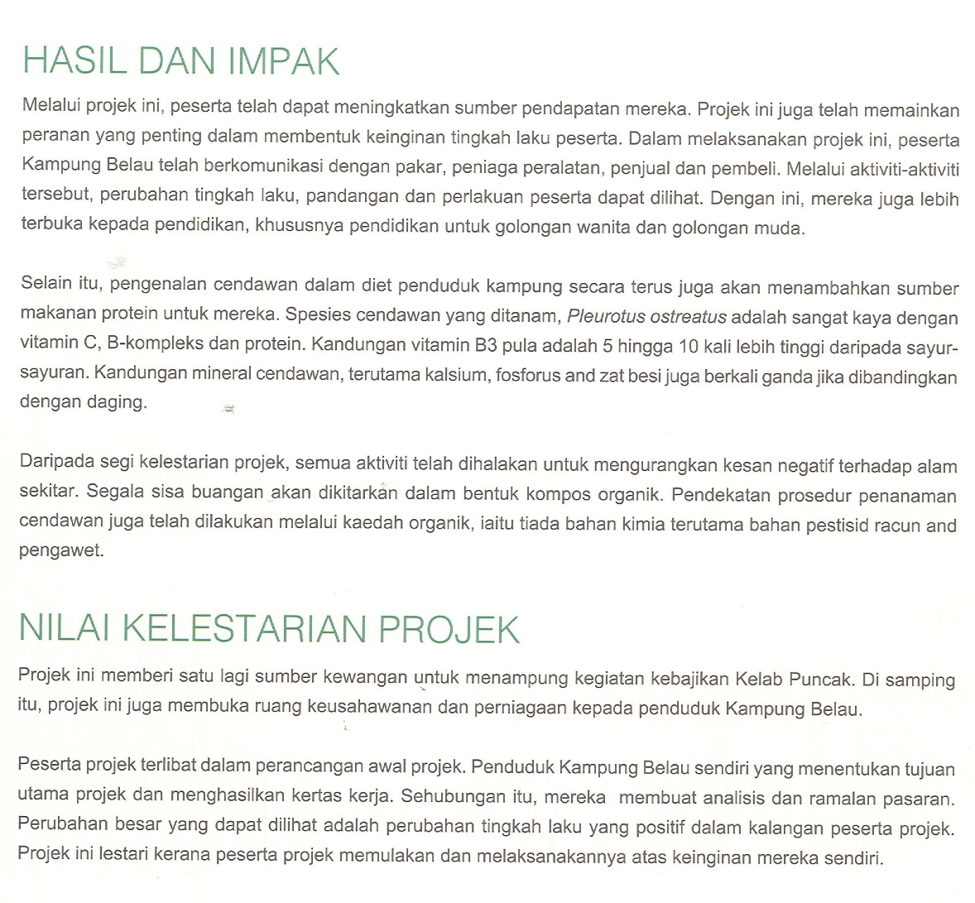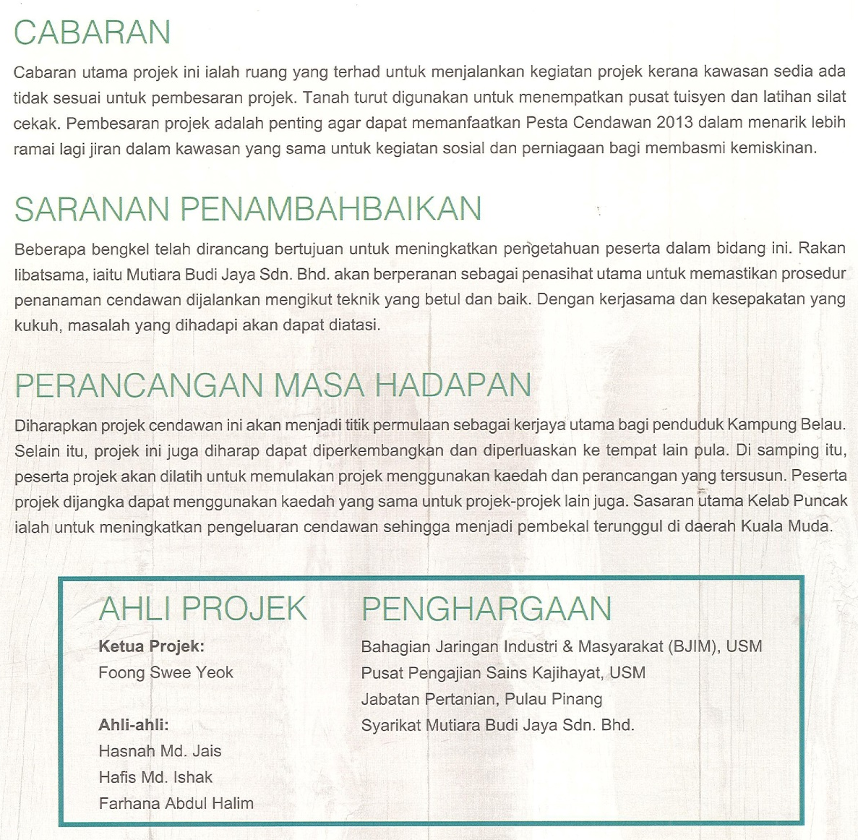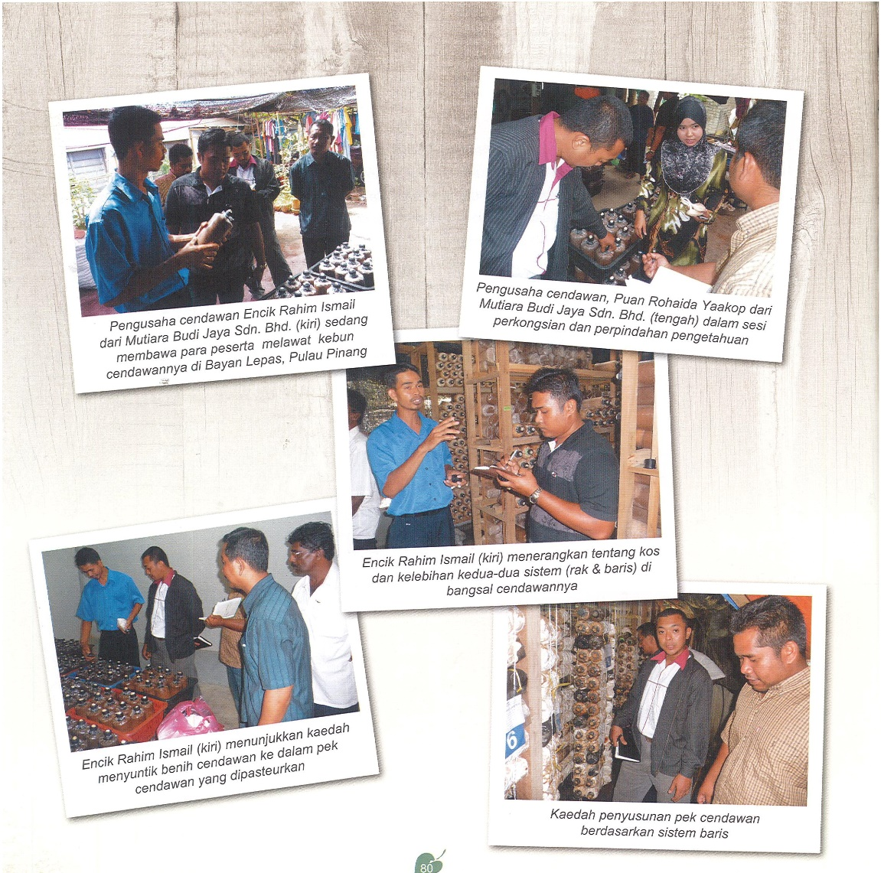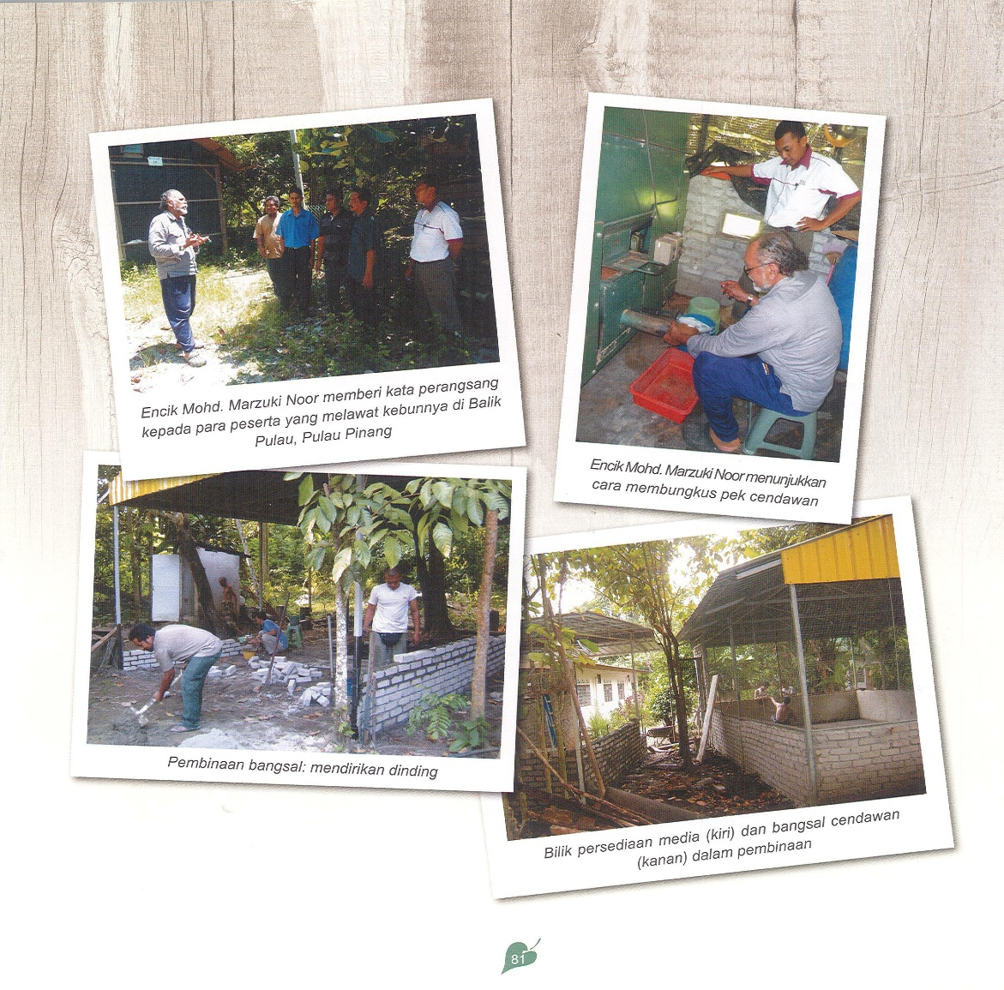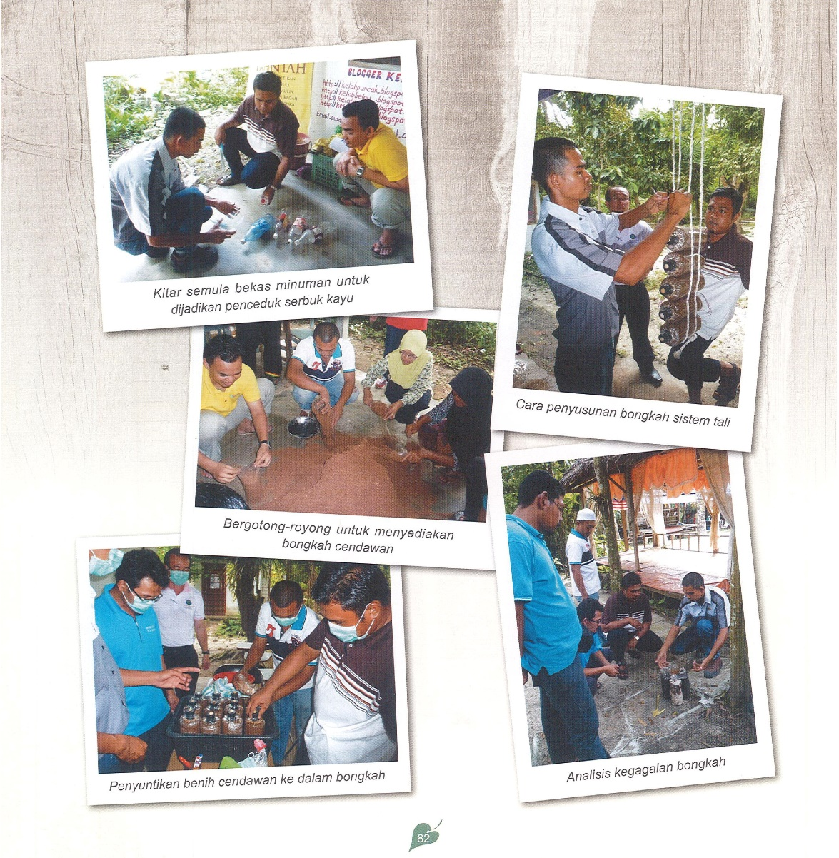
*contoh artikel berdasarkan buku pelaporan komuniti usm

